Xz3
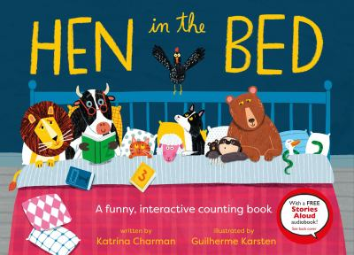
Recommended books:
Bunny Should be Sleeping by Amy Hest
Sleep, Little Dozer by Diana Murray
The Band in our Basement By Kelly J. Baptist
Hello Moon By Julie Downing
Owl Babies by Martin Waddell
Good Night, Little Man by Daniel Bernstrom

Hen in the Bed
By Katrina Charman
Illustrated by Guilherme Karsten

Fingerplays, Flannel Boards, and Action Rhymes:
Twinkle, Twinkle Little Star
Twinkle, twinkle, little star (open and close hands like flashing motion)
How I wonder what you are (shrug shoulders and put hands out palm up)
Up above the world so high (point up to the sky)
Like a diamond in the sky (put your thumbs together, and pointer fingers together, to make a diamond shape)
Twinkle, twinkle, little star (open and close hands like flashing motion)
How I wonder what you are! (shrug shoulders and put hands out palm up)
Source: Jbrary

Teddy Bear Teddy Bear
Teddy bear, teddy bear, turn around
Teddy bear, teddy bear, touch the ground Teddy bear, teddy bear, show your shoe Teddy bear, teddy bear, I love you
Teddy bear, teddy bear, climb upstairs Teddy bear, teddy bear, brush your hair Teddy bear, teddy bear, turn out the light Teddy bear, teddy bear, say “Goodnight!”
Bear in the Lair Flannel Board
Sleepy bear, sleepy bear, are you in the (color) lair?
Source: Lady Librarian
This Little Boy Fingerplay
This little boy is ready for bed (hold up index finger)
Down on the pillow he lays his head (place index finger in the palm of other hand)
Wraps himself in his covers tight (hand wrapped around finger)
And here he sleeps all the night (rock hands back and forth)
Source: Jen in the Library
Songs:
We are the Dinosaurs by Laurie Berkner
Sleeping Bag Chant by Miss Carole
Hop Little Bunnies by Ms. Rachel

Activity:
Tuck Me In Teddy from Jen in the Library
