
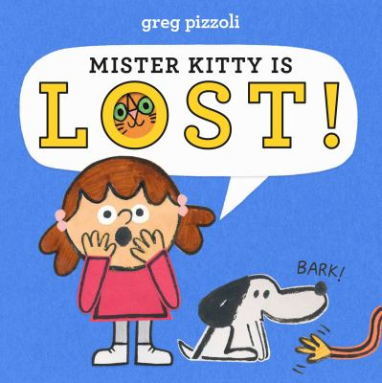
Recommended books:
10 Cats by Emily Gravett
Cat’s Very Good Day by Kristen Tracy
Pete the Cat: I Love My White Shoes By Eric Litwin
Bathe the Cat By Alice B. McGinty
Kitten’s First Full Moon by Kevin Henkes
Stack the Cats by Susie Ghahremani

Mister Kitty is Lost
By Greg Pizzoli

Fingerplays, Flannel Boards, and Action Rhymes:
Three Little Kittens
(Flannelboard)
Source: Adventures in Storytime
Kitty Cat Pounce
(Use with scarves)
Kitty cat, kitty cat sneaks out of the house.
Kitty cat, kitty cat creeps up to a mouse,
And… POUNCE!
Kitty cat, kitty cat, creeps up to a bird.
Kitty cat, kitty cat, is not even heard,
And… POUNCE!
But the mouse ran, and the bird flew away,
So kitty cat found a ball of yarn to play
And… POUNCE!
Source: Pasadena Library
I Have a Cat
I have a cat (pet imaginary cat).
My cat lies flat (put one hand flat on top of the other).
I have a cat (pet imaginary cat).
She wears a hat (pat the top of your head).
I have a cat (pet imaginary cat).
She caught a rat (grab imaginary rat).
I have a cat (pet imaginary cat).
Purr, Purr, MEOW!
Source: Loudest Librarian
Five Little Kittens
Five little kittens standing in a row.
(Stand all five fingers up on one hand)
They nod their heads to the children so.
(Bend your fingers in a ”nod”)
They run to the left, they run to the right.
(Move hand/fingers to the left, then right)
They stand up and stretch in the bright sunlight.
(Stand fingers, stretching high)
Along comes a dog, who’s in for some fun.
(Bring other hand out like a dog chasing)
M-e-oooow, see those kittens run!
(Have hand “run” behind back)
Source: Handley Regional LIbrary
Songs:
Creepy Mouse/Sneaky Cat by Miss Carole
When Cats Get Up in the Morning by Old Town School of Folk Music

Activity:
Easy cat craft from Crafts on Sea
