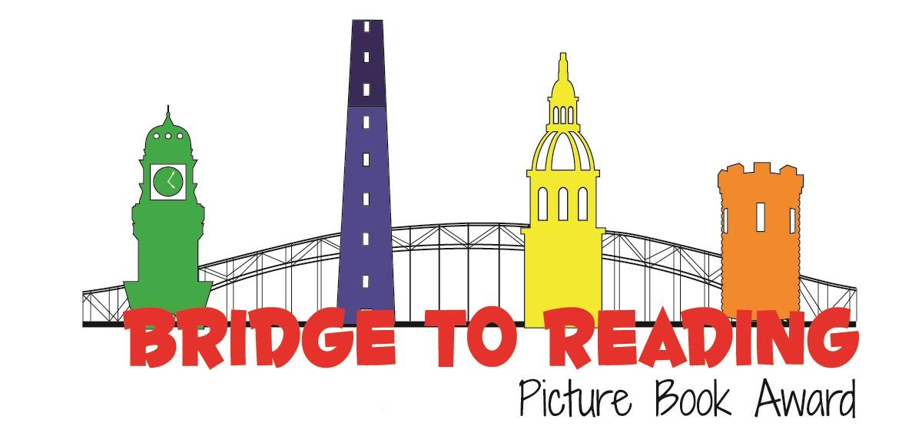
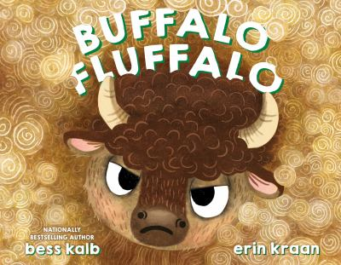
Recommended books:
It’s Okay to Be a Unicorn by Jason Tharp
Big by Vashti Harrison
Sour Apple By Linda Liu
Kick Push By Frank Morrison
Pete the Cat and the Cool Cat Boogie by Kim Dean
The Mixed Up Chameleon by Eric Carle

Buffalo Fluffalo
By Bess Kalb
Illustrated by Erin Kraan

Fingerplays and Action Rhymes:
All of Me
My hands are for clapping, my arms can hug tight.
My fingers can wiggle, or turn out the light
My legs are for jumping, my eyes can see This is my body and I love all of me!

Source: Storytime with Ms. Emily Library

Eyes, Nose, Cheeky, Cheeky, Chin!
Eyes, nose, cheeky cheeky chin (x3)
Cheeky cheeky chin, nose, eyes

Wiggle your nose and give us a grin (x3)
Cheeky cheeky chin, nose, eyes

Wink one eye, cheeky cheeky chin (x2)
Cheeky cheeky chin, nose, eyes.

Source: The Alana Banana Show & Music with Shannon

I Have Ten Fingers
I have ten fingers
And they all belong to me,
I can make them do things-
Would you like to see?
I can shut them up tight
I can open them wide
I can put them together
I can make them all hide
I can make them jump high
I can make them jump low
I can fold them up quietly
And hold them just so.

Flannel: Make a Pig
If you prefer, this would be easy to make into a buffalo! Work together with children to describe what body parts a pig should have!
Source: Book Cart Queens

Flannel: The Ugly Duckling by Hans Christian Andersen
Simple directions from: Born Librarian
Songs:
You’re Never Fully Dressed Without a Smile by Annie Soundtrack (use with shaker eggs)
Skinnamarink by Sharon, Lois, & Bram

Activity:
Body Tracing Art from: The Artful Parent.
