
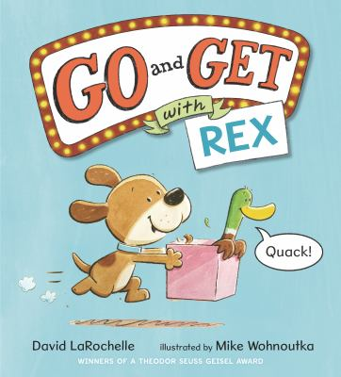
Recommended books:
Chicka Chicka Boom Boom by Bill Martin, Jr. and John Archambault
Be My Yummy ABC by Joyce Wan
Albert’s ABCs: A Sibling Story By Henry Cole
B is for Baby By Atinuke
What About X?: An Alphabet Adventure by Anne Marie Houppert
Bear is Awake by Hannah E. Harrison

Go and Get with Rex
By David LaRochelle
Illustrated by Mike Wohnoutka

Fingerplays, Flannel Boards, and Action Rhymes:
Alpha-Beat
First clap your hands.
Then stomp your feet.
Everybody do the alphabet beat.
Apple, Apple, Apple – a – a – a,
Apple, Apple, Apple – a – a – a,
Wave your arms high.
Swing your arms low.
The alphabet beat is the way to go.
Blue, Blue, Blue – b – b – b
Blue, Blue, Blue – b – b – b
Move to the left. Move to the right.
The alphabet beat is way out of sight.
Car, Car, Car – c – c – c
Car, Car, Car – c – c – c
Now give a high five to a nearby friend.
The alphabet beat has come to the end!
Source: Storytime Katie
Big A, Little A
Big A, Little a, (spread hands wide apart, then bring them close together)
Bouncing B (bounce up and down)
The cat’s in the cupboard
And he can’t see me (cover your eyes with your hands)
Peek-a-boo!
Tune: Loudest Librarian
Five Little Ducks (Sing the song on its own, or do a flannel board)
Five little ducks went out to play, over the hill and far away
Mother duck said, “Quack, quack, quack, quack”
And only four little ducks came back
(count down until)
Sad mother duck went out one day, over the hill and far away
Mother duck said, “Quack, quack, quack, quack”
And all of her five little ducks came back
Source: Storytime Katie
Heart Fingerplay
I put my hands together,
This is how I start
I curve my fingers right around,
And I can make a heart!
Source: Jbrary
Songs:
The More We Get Together by Laurie Berkner
Run Baby Run by Caspar Babypants

Activity:
Easy chick craft from masandpas.com
