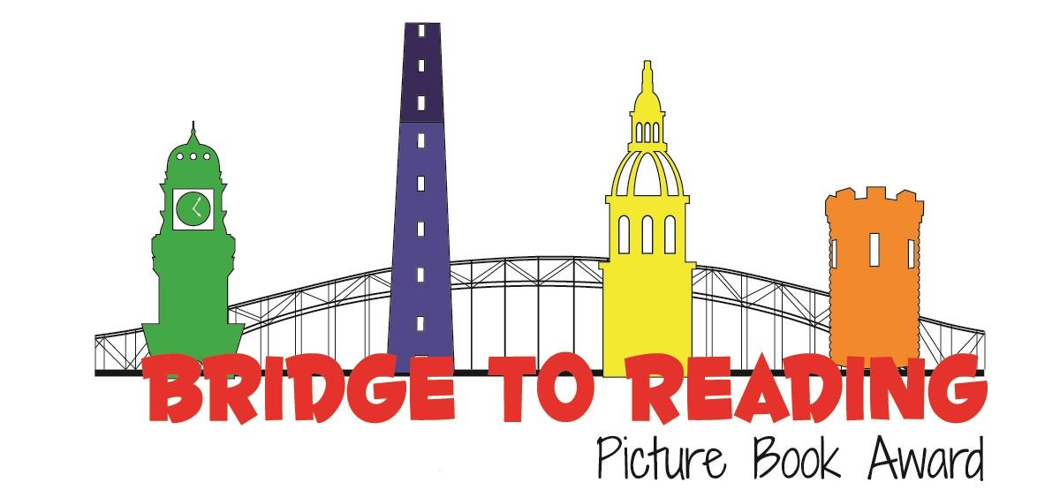
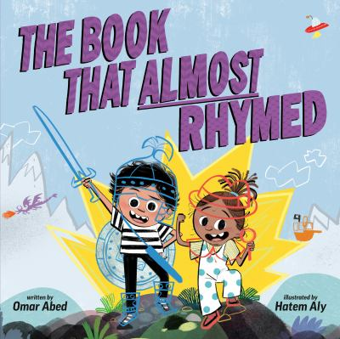
Recommended books:
On Our Way!: What a Day! by JaNay Brown-Wood
Chooch Helped by Andrea L. Rogers
The Brother Book/The Sister Book By Todd Parr
Annie Rose is My Little Sister By Shirley Hughes
Maple by Lori Nichols
Lola Reads to Leo by Anna McQuinn

The Book That Almost Rhymed
By Omar Abed
Illustrated by Hatem Aly

Fingerplays, Flannel Boards, and Action Rhymes:
The Three Billy Goats Gruff
(Flannelboard) - can use finger puppets or flannel/laminated magnet animals for this)
The traditional story can be found online.
Where is Thumbkin?
(You can replace the traditional words with sister, brother, cousin, etc)
Start by holding your hands behind your back:
“Where is Thumbkin? Where is Thumbkin?”
Bringing out one hand with thumb up: “Here I am!”
Other side: “Here I am!”
Thumbs “talking” to each other: “How are you today, Sir?” “Very well, I thank you.”
Returning thumbs behind back: “Run away. Run away.”
Repeat with “Pointer,” “Tall Man,” “Ring Man,” and “Pinkie.”

Tune: Super Simple Songs
Five Little Ducks (Sing the song on its own, or do a flannel board)
Five little ducks went out to play, over the hill and far away
Mother duck said, “Quack, quack, quack, quack”
And only four little ducks came back
(count down until)
Sad mother duck went out one day, over the hill and far away
Mother duck said, “Quack, quack, quack, quack”
And all of her five little ducks came back
Source: Storytime Katie
Heart Fingerplay
I put my hands together,
This is how I start
I curve my fingers right around,
And I can make a heart!
Source: Jbrary
Songs:
The More We Get Together by Laurie Berkner
Run Baby Run by Caspar Babypants

Activity:
Just like the siblings in the book work together, classrooms and libraries can work together on a huge painting activity!
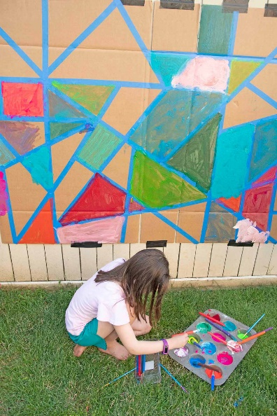
Source: Busy Toddler

