
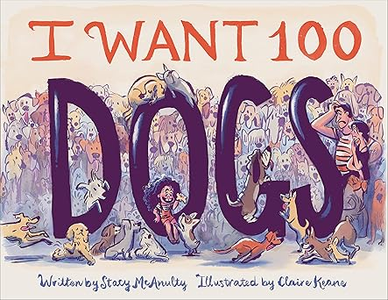
Recommended books:
Just Like Millie by Lauren Castillo
Don’t Eat Bees by Dev Petty
I Want a Dog By Jon Agee
Simon & the Better Bone By Corey Tabor
Two Together by Brendan Wenzel
Go & Get with Rex by David LaRochelle

I Want 100 Dogs
By Stacy McAnulty
Illustrated by Claire Keane

Fingerplays and Action Rhymes:
Ten Little Doggies
Ten little doggies went out one day, (hold up ten fingers)
To dig in the dirt and play, play, play. (dig, clap on each ‘play’)
Five were spotted, and five were not, (hold up one hand, then the other)
And at dinnertime they ate a lot! (pretend to eat).

The Paws on the Dog
(Tune: Wheels on the Bus)
The paws on the dog go trot, trot, trot, (slap hands on thigh or floor) Trot, trot, trot, trot, trot, trot, The paws on the dog go trot, trot, trot, All through the town.
The ears on the dog go flop, flop, flop.. (flop head side to side)
The nose on the dog goes sniff, sniff, sniff.. The tongue on the dog goes lick, lick, lick.. The bark on the dog goes woof, woof, woof.
The tail on the dog goes wag, wag, wag.. The people with the dogs say, "SIT!" “SIT!” “SIT!”
If You’re a Pet and You Know It
(tune: If You’re Happy and You Know It)
If you’re a dog and you know it, Say, “Woof, woof”. If you’re a dog and you know it, Say, “Woof, woof”. If you’re a dog and you know it, And you really want to show it. If you’re a dog and you know it, Say, “Woof, woof”.
Repeat with: Kitty/Meow
Fishy/Blub
Hamster/Run in place
Bird/Tweet
Songs:
Where Has My Little Dog Gone by Cocomelon
BINGO by Super Simple Songs
Activity:
Easy dog craft from https://simplemomproject.com/build-a-dog-craft/

