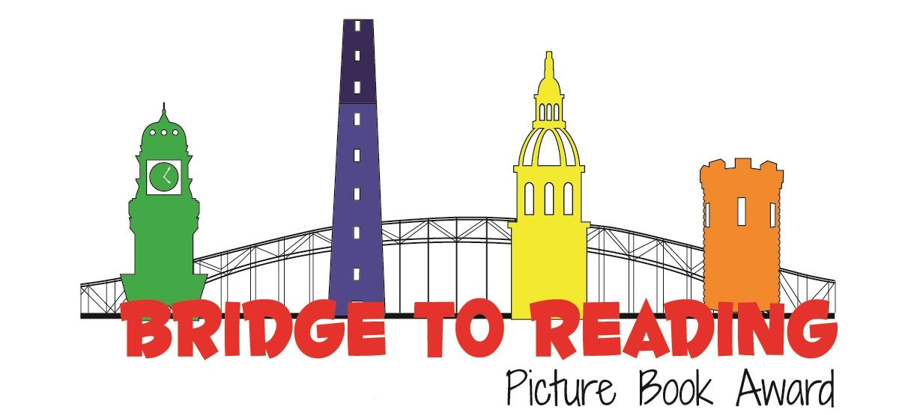
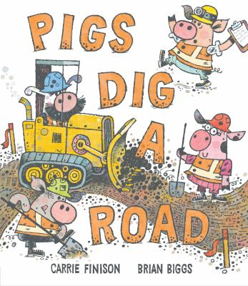
Recommended books:
Hard Hat Hank and the Sky High Solution by Charlotte Gunnufson
Construction Site: Road Crew Coming Through by Sherri Rinker
Snakes on the Job By Kathryn Dennis
Tinyville Town Gets to Work By Brian Biggs
Go! Go! Go! Stop! by Charise Mericle Harper
Kitten and the Night Watchman by John Sullivan

Pigs Dig a Road
By Carrie Finison
Illustrated by Hatem Aly

Fingerplays, Flannel Boards, and Action Rhymes:
Tower
We’re making a tower (fists stack atop each other)
In our building-block town
Along comes the baby… (fingers wiggle)
…And it all falls down! (hands fall outward)
Source: Storytime with Ms. Emily Library
Cranes Reach High
Cranes reach up
Cranes reach down
Cranes reach out and all around.

Tune: jbrary
Red Crane, Red Crane flannel board
Red crane, red crane, what do you see?
I see a yellow digger looking at me.
Yellow digger, yellow digger, what do you see?
I see a purple mixer looking at me.
(etc.)

Source: Storytime Katie
Johnny Works with One Hammer
Johnny works with one hammer,
One hammer, 1 hammer,
Johnny works with 1 hammer,
Then he works with two.
(Hammer one fist lightly on leg)

Two hammers
(Hammer both fists on legs)

Three hammers
(Hammer both fists on legs and one foot on the floor)

Four hammers
(Hammer both fists on legs and both feet on the floor)

Johnny works with five hammers,
Five hammers, five hammers,
Johnny works with five hammers
(Hammer both fists on legs, both feet on floor, and nod head down and up)
Then he goes to sleep.
(Rest head on joined palms, pretending to go to sleep)

Source: Songs for Teaching
Songs:
Hammer and Saw by Jim Gill
Disco Hippo by Caspar Babypants

Activity:
Painting with Trucks from Learn Play Imagine


