
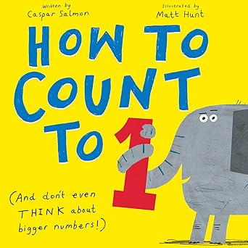
Recommended books:
Pete the Cat and His Four Groovy Buttons by Eric Litwin
Is This the Bus for Us? by Harriet Ziefert
Everything a Drum By Sarah Warren
Have You Seen My Invisible Dinosaur By Helen Yoon
The Duck Never Blinks by Alex Latimer
You Rule by Rilla Alexander

How to Count to 1
By Caspar Salmon
Illustrated by Matt Hunt

Fingerplays and Action Rhymes:
All the Little Ducks Go Upside Down
All the little ducks go upside down,
upside down, upside down,
All the little ducks go upside down
as they dabble at the bottom of the pond.
All their little beaks go snap, snap, snap,
snap, snap, snap, snap, snap, snap,
All their little beaks go snap, snap, snap,
as they dabble at the bottom of the pond.

All their little tails go wiggle, waggle, wiggle,
wiggle, waggle, wiggle, wiggle, waggle, wiggle,
All their little tails go wiggle, waggle, wiggle,
as they dabble at the bottom of the pond.

How Many Fingers?
[song by Super Simple Songs]
How many fingers on one hand, how many fingers on one hand, how many fingers on one hand.
Let’s all count together (hold up fingers as you count)
1, 2, 3, 4, 5
1, 2, 3, 4, 5
1, 2, 3, 4, 5
How many fingers on two hands, how many fingers on two hands, how many fingers on two hands
Let’s all count together (hold up fingers as you count)
1, 2, 3, 4, 5, 6, 7, 8, 9, 10
1, 2, 3, 4, 5, 6, 7, 8, 9, 10
1, 2, 3, 4, 5, 6, 7, 8, 9, 10
(clap your hands)
Clap, clap, clap your hands
Clap, clap, clap your hands
Clap, clap, clap your hands
Clap your hands with me

Five eggs
(fingerplay or flannel/magnet board)
5 eggs and 5 eggs, and that makes 10 (make fists)
Sitting on top is the mother hen (open up hand and sit it on your eggs)
Cackle, cackle, cackle, and what do I see? (clap on the cackle’s)
10 fuzzy chicks, as cute as can be!
Source: Storytime Katie
Songs:
Seven Steps by Super Simple Songs
Ten in the Bed by Super Simple Songs
Activity:
Go back through the book and count the other items on each page. Is it more than one? How many are there total?
Use building blocks or Legos to count

